**Week 7**

Php-

Developed the backend for enrol and unroll for the project

Screenshots:-

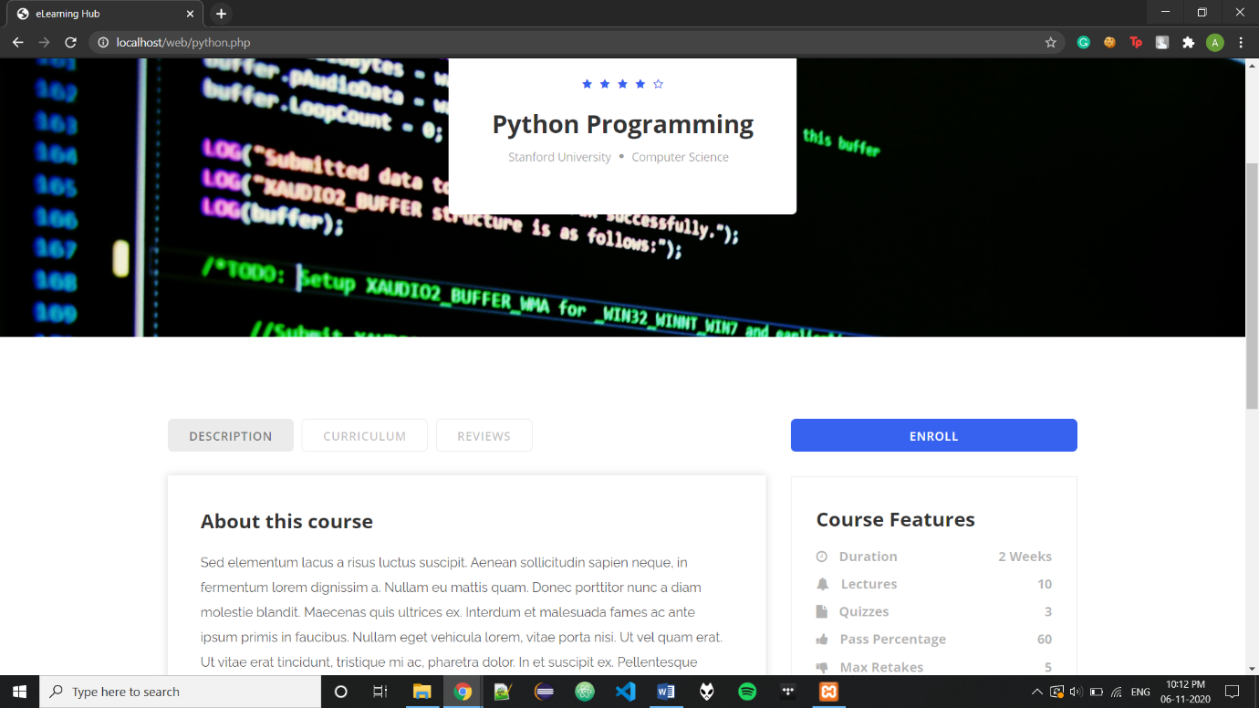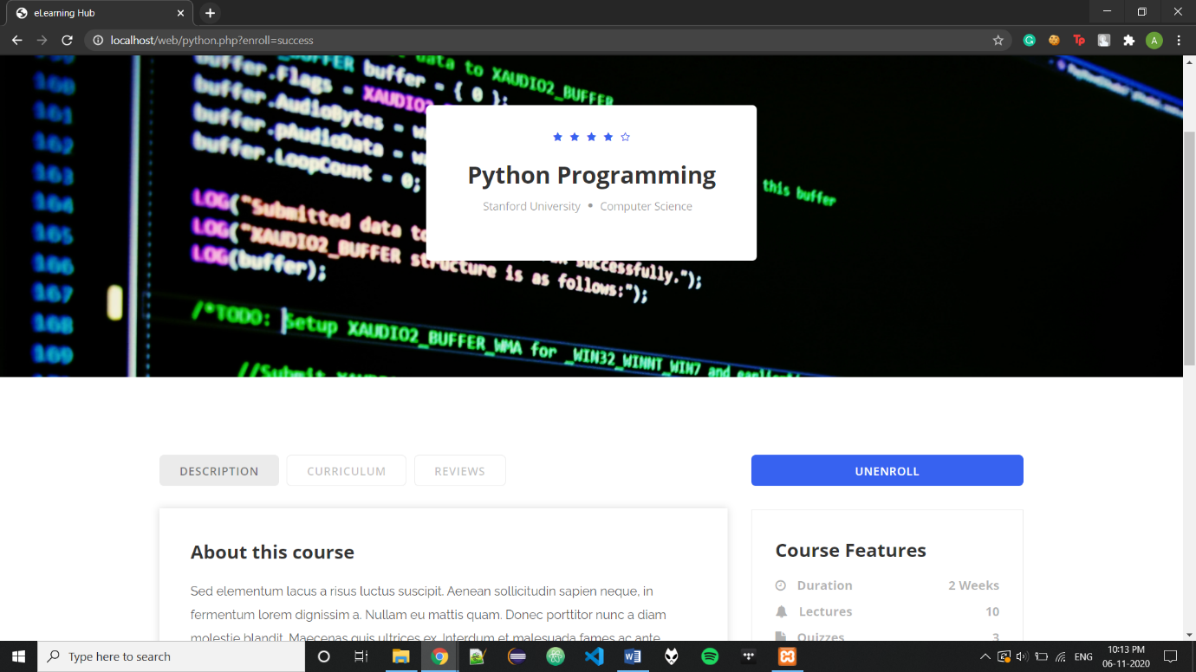

Code:-

**Enroll.inc.php:-**

<?php

session_start();

require 'dbh.inc.php';

if(isset($_POST['cplusplus'])) {

echo '<script>alert("c++")</script>';

$sql = "INSERT into courses_(course_name, u_email) Values(?,?);";

$stmt = mysqli_stmt_init($conn);

if(!mysqli_stmt_prepare($stmt,$sql)){

header("Location: ../cplusplus.php?error");

exit();

}

else{

$course = 'cplusplus';

mysqli_stmt_bind_param($stmt,"ss", $course,$_SESSION['uEmail']);

mysqli_stmt_execute($stmt);

header("Location: ../cplusplus.php?enroll=success");

exit();

}

}

if(isset($_POST['python'])) {

echo '<script>alert("c++")</script>';

$sql = "INSERT into courses_(course_name, u_email) Values(?,?);";

$stmt = mysqli_stmt_init($conn);

if(!mysqli_stmt_prepare($stmt,$sql)){

header("Location: ../python.php?error");

exit();

}

else{

$course = 'python';

mysqli_stmt_bind_param($stmt,"ss", $course,$_SESSION['uEmail']);

mysqli_stmt_execute($stmt);

header("Location: ../python.php?enroll=success");

exit();

}

}

if(isset($_POST['java'])) {

echo '<script>alert("c++")</script>';

$sql = "INSERT into courses_(course_name, u_email) Values(?,?);";

$stmt = mysqli_stmt_init($conn);

if(!mysqli_stmt_prepare($stmt,$sql)){

header("Location: ../java.php?error");

exit();

}

else{

$course = 'java';

mysqli_stmt_bind_param($stmt,"ss", $course,$_SESSION['uEmail']);

mysqli_stmt_execute($stmt);

header("Location: ../java.php?enroll=success");

exit();

}

}

if(isset($_POST['machinelearning'])) {

echo '<script>alert("c++")</script>';

$sql = "INSERT into courses_(course_name, u_email) Values(?,?);";

$stmt = mysqli_stmt_init($conn);

if(!mysqli_stmt_prepare($stmt,$sql)){

header("Location: ../machinelearning.php?error");

exit();

}

else{

$course = 'machinelearning';

mysqli_stmt_bind_param($stmt,"ss", $course,$_SESSION['uEmail']);

mysqli_stmt_execute($stmt);

header("Location: ../machinelearning.php?enroll=success");

exit();

}

}

if(isset($_POST['cryptography'])) {

echo '<script>alert("c++")</script>';

$sql = "INSERT into courses_(course_name, u_email) Values(?,?);";

$stmt = mysqli_stmt_init($conn);

if(!mysqli_stmt_prepare($stmt,$sql)){

header("Location: ../cryptography.php?error");

exit();

}

else{

$course = 'cryptography';

mysqli_stmt_bind_param($stmt,"ss", $course,$_SESSION['uEmail']);

mysqli_stmt_execute($stmt);

header("Location: ../cryptography.php?enroll=success");

exit();

}

}

if(isset($_POST['gamedevelopment'])) {

echo '<script>alert("c++")</script>';

$sql = "INSERT into courses_(course_name, u_email) Values(?,?);";

$stmt = mysqli_stmt_init($conn);

if(!mysqli_stmt_prepare($stmt,$sql)){

header("Location: ../gamedevelopment.php?error");

exit();

}

else{

$course = 'gamedevelopment';

mysqli_stmt_bind_param($stmt,"ss", $course,$_SESSION['uEmail']);

mysqli_stmt_execute($stmt);

header("Location: ../gamedevelopment.php?enroll=success");

exit();

}

}

if(isset($_POST['dsalso'])) {

echo '<script>alert("c++")</script>';

$sql = "INSERT into courses_(course_name, u_email) Values(?,?);";

$stmt = mysqli_stmt_init($conn);

if(!mysqli_stmt_prepare($stmt,$sql)){

header("Location: ../dsalso.php?error");

exit();

}

else{

$course = 'dsalso';

mysqli_stmt_bind_param($stmt,"ss", $course,$_SESSION['uEmail']);

mysqli_stmt_execute($stmt);

header("Location: ../dsalso.php?enroll=success");

exit();

}

}

if(isset($_POST['mobile'])) {

echo '<script>alert("c++")</script>';

$sql = "INSERT into courses_(course_name, u_email) Values(?,?);";

$stmt = mysqli_stmt_init($conn);

if(!mysqli_stmt_prepare($stmt,$sql)){

header("Location: ../mobile.php?error");

exit();

}

else{

$course = 'mobile';

mysqli_stmt_bind_param($stmt,"ss", $course,$_SESSION['uEmail']);

mysqli_stmt_execute($stmt);

header("Location: ../mobile.php?enroll=success");

exit();

}

}

if(isset($_POST['dbms'])) {

echo '<script>alert("c++")</script>';

$sql = "INSERT into courses_(course_name, u_email) Values(?,?);";

$stmt = mysqli_stmt_init($conn);

if(!mysqli_stmt_prepare($stmt,$sql)){

header("Location: ../dbms.php?error");

exit();

}

else{

$course = 'dbms';

mysqli_stmt_bind_param($stmt,"ss", $course,$_SESSION['uEmail']);

mysqli_stmt_execute($stmt);

header("Location: ../dbms.php?enroll=success");

exit();

}

}

**Unenroll.inc.php:-**

<?php

session_start();

require 'dbh.inc.php';

if(isset($_POST['cplusplus'])) {

echo '<script>alert("c++")</script>';

$sql = "Delete from courses_ where course_name = ? and u_email=?;";

$stmt = mysqli_stmt_init($conn);

if(!mysqli_stmt_prepare($stmt,$sql)){

header("Location: ../cplusplus.php?error");

exit();

}

else{

$course = 'cplusplus';

mysqli_stmt_bind_param($stmt,"ss", $course,$_SESSION['uEmail']);

mysqli_stmt_execute($stmt);

header("Location: ../cplusplus.php?enroll=success");

exit();

}

}

if(isset($_POST['python'])) {

echo '<script>alert("c++")</script>';

$sql = "Delete from courses_ where course_name = ? and u_email=?;";

$stmt = mysqli_stmt_init($conn);

if(!mysqli_stmt_prepare($stmt,$sql)){

header("Location: ../python.php?error");

exit();

}

else{

$course = 'python';

mysqli_stmt_bind_param($stmt,"ss", $course,$_SESSION['uEmail']);

mysqli_stmt_execute($stmt);

header("Location: ../python.php?enroll=success");

exit();

}

}

if(isset($_POST['java'])) {

echo '<script>alert("c++")</script>';

$sql = "Delete from courses_ where course_name = ? and u_email=?;";

$stmt = mysqli_stmt_init($conn);

if(!mysqli_stmt_prepare($stmt,$sql)){

header("Location: ../java.php?error");

exit();

}

else{

$course = 'java';

mysqli_stmt_bind_param($stmt,"ss", $course,$_SESSION['uEmail']);

mysqli_stmt_execute($stmt);

header("Location: ../java.php?enroll=success");

exit();

}

}

if(isset($_POST['machinelearning'])) {

echo '<script>alert("c++")</script>';

$sql = "Delete from courses_ where course_name = ? and u_email=?;";

$stmt = mysqli_stmt_init($conn);

if(!mysqli_stmt_prepare($stmt,$sql)){

header("Location: ../machinelearning.php?error");

exit();

}

else{

$course = 'machinelearning';

mysqli_stmt_bind_param($stmt,"ss", $course,$_SESSION['uEmail']);

mysqli_stmt_execute($stmt);

header("Location: ../machinelearning.php?enroll=success");

exit();

}

}

if(isset($_POST['cryptography'])) {

echo '<script>alert("c++")</script>';

$sql = "Delete from courses_ where course_name = ? and u_email=?;";

$stmt = mysqli_stmt_init($conn);

if(!mysqli_stmt_prepare($stmt,$sql)){

header("Location: ../cryptography.php?error");

exit();

}

else{

$course = 'cryptography';

mysqli_stmt_bind_param($stmt,"ss", $course,$_SESSION['uEmail']);

mysqli_stmt_execute($stmt);

header("Location: ../cryptography.php?enroll=success");

exit();

}

}

if(isset($_POST['gamedevelopment'])) {

echo '<script>alert("c++")</script>';

$sql = "Delete from courses_ where course_name = ? and u_email=?;";

$stmt = mysqli_stmt_init($conn);

if(!mysqli_stmt_prepare($stmt,$sql)){

header("Location: ../gamedevelopment.php?error");

exit();

}

else{

$course = 'gamedevelopment';

mysqli_stmt_bind_param($stmt,"ss", $course,$_SESSION['uEmail']);

mysqli_stmt_execute($stmt);

header("Location: ../gamedevelopment.php?enroll=success");

exit();

}

}

if(isset($_POST['dsalso'])) {

echo '<script>alert("c++")</script>';

$sql = "Delete from courses_ where course_name = ? and u_email=?;";

$stmt = mysqli_stmt_init($conn);

if(!mysqli_stmt_prepare($stmt,$sql)){

header("Location: ../dsalso.php?error");

exit();

}

else{

$course = 'dsalso';

mysqli_stmt_bind_param($stmt,"ss", $course,$_SESSION['uEmail']);

mysqli_stmt_execute($stmt);

header("Location: ../dsalso.php?enroll=success");

exit();

}

}

if(isset($_POST['mobile'])) {

echo '<script>alert("c++")</script>';

$sql = "Delete from courses_ where course_name = ? and u_email=?;";

$stmt = mysqli_stmt_init($conn);

if(!mysqli_stmt_prepare($stmt,$sql)){

header("Location: ../mobile.php?error");

exit();

}

else{

$course = 'mobile';

mysqli_stmt_bind_param($stmt,"ss", $course,$_SESSION['uEmail']);

mysqli_stmt_execute($stmt);

header("Location: ../mobile.php?enroll=success");

exit();

}

}

if(isset($_POST['dbms'])) {

echo '<script>alert("c++")</script>';

$sql = "Delete from courses_ where course_name = ? and u_email=?;";

$stmt = mysqli_stmt_init($conn);

if(!mysqli_stmt_prepare($stmt,$sql)){

header("Location: ../dbms.php?error");

exit();

}

else{

$course = 'dbms';

mysqli_stmt_bind_param($stmt,"ss", $course,$_SESSION['uEmail']);

mysqli_stmt_execute($stmt);

header("Location: ../dbms.php?enroll=success");

exit();

}

}